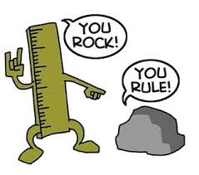
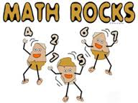

Student Feedback Form

Please circle one of the following numbers to describe your feelings about the activities we completed on the topic of _____________________.

1  I enjoyed none of the activities. | 2  I enjoyed a few of the activities | 3  I enjoyed some of the activities | 4  I enjoyed most of the activities | 5  I enjoyed all of the activities

Please describe why you circled the number in the space below ☺
(For example: most favorite/least favorite activities, working with others, watching the video at home, etc.)

Thank You ☺

